9.1-1)
In a decision tree for sorting n elements( a1 to an), the smallest possible depth of a leaf corresponds to the smallest number of comparisons needed to establish a sorting order among the elements. This happens when you get comparison decisions of the
form a_{i1} < a_{i2,} a_{i2} < a_{i3,} a_{i3}< a_{i4,}…. a_{i4} < a_{in} , where i1, i2, i3.. span the set 1..n. So the smallest number of comparisons by which you can obtain an ordering among the n elements is n-1.
Thus, the smallest possible depth of a leaf is n-1.

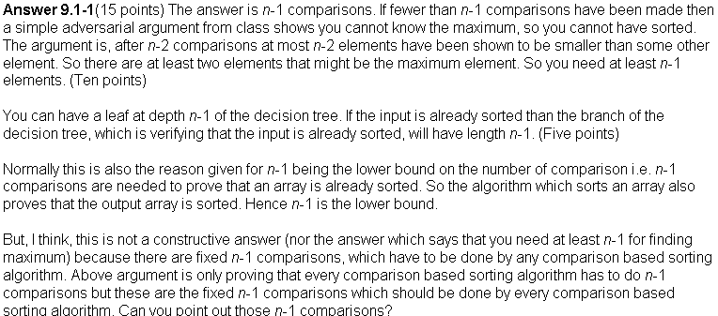

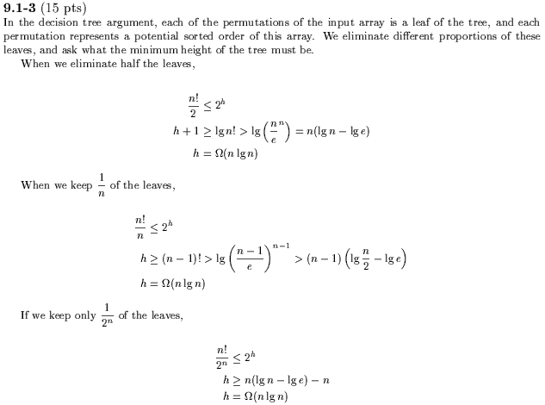

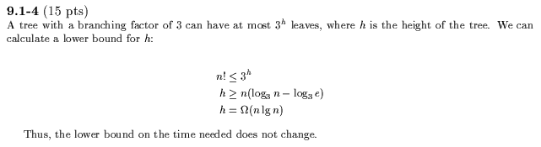

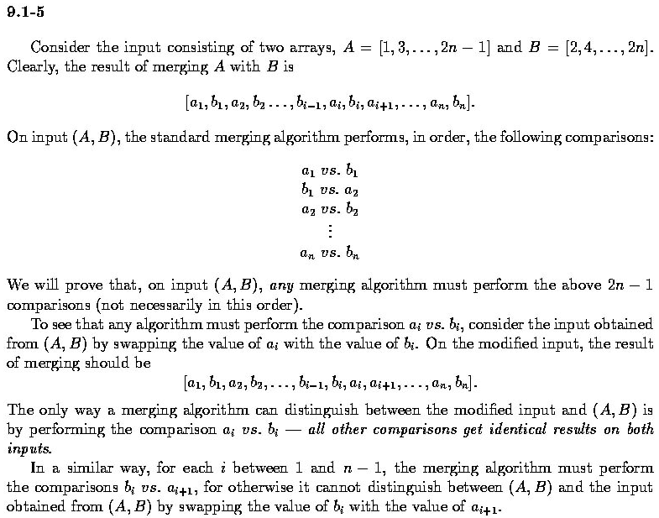

9.1-6)
Assume that there exists a decision tree of height h to sort this sequence.
Since there are n/k subsequences each containing k elements, which are sorted relatively among themselves, there are at least a total of (k!)^{n/k} possible outcomes at the leaves of the decision tree – since each subsequence can be sorted in k! ways, and there are n/k subsequences. So the number of leaves of the tree, 2^{h} > (k!)^{n/k} , taking log on both sides,
We get h>n/k lg(k!) or h > nlg k. So you need at least Ω(n lg k) comparison steps.

